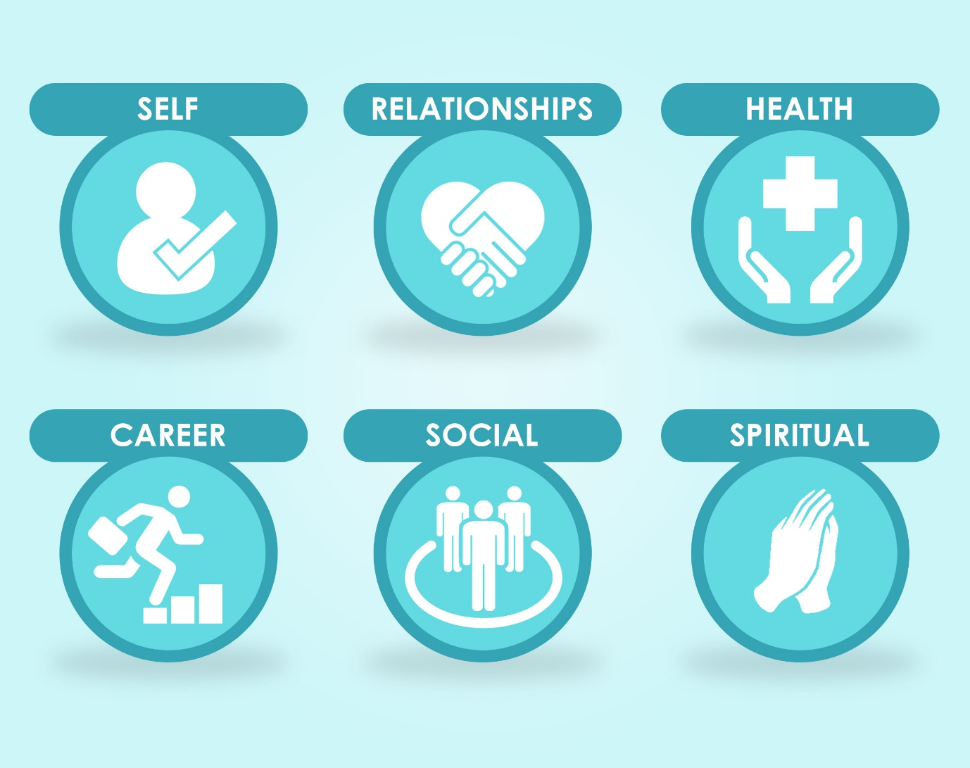

Module 1 b Motivation
Motivation is what keeps us going. It is the reason people succeed and the reason people fail. Motivation is the drive somebody has to complete a task. The ingredients of motivation are combined with many factors which include simplicity, attitude, the people you hang around with, the way you think, knowing yourself, helping other people and so much more. In this sub module I will take you through methods you can practise on a daily basis to remain motivated. These techniques can help you feel better about yourself in everything you do. You can take these methods with you when you go to work and when you are at home.
Motivation is the spark everyone needs to make it through the day, to set and meet goals and more. Without motivation you will fail. When you know how to remain motivated, you will be able to help others as your attitude will be contagious. When you practise these daily techniques, they will eventually come naturally. It will take time however. In this module I will share with you 7 keys to how to stay more motivated in your life. I have applied all of these in my life, and it is amazing what happens if you do. So let’s get into those all-important 7 keys.
Key 1: Simplicity
This may sound very simple and it is supposed to, however it will make a big difference in your life. When thinking about motivation, the first thing you need to do is create space around you at work and at home. This space needs to remain simple and positive. The things around you have a lot to do with the way you feel, so space is great. I am not telling you to move house, but there are some things you can do to change what is around you. Your office space for instance, should contain and display items that make you feel positive about life and about reaching goals. If you have goals and things you would like to do it might be a good idea to post these things on the wall in and around your desk/office. This way you will be reminded of the things you want to do in your life.
This positivity needs to be everywhere where you are. If you spend hours driving in your car, ensure it is a positive space. Clean it up! Don’t drive around in a depressing car that is full of trash and paperwork. You will be surprised how good you will feel when you clean up your car.
A messy and dirty home can be depressing and disabling. Many people sit around for hours procrastinating in a messy home. It’s amazing how good a clean and decluttered home can make you feel. Clean up the mess in your shed/garage/loft/cellar. Get rid of clothes you have not worn for years. One little trick I will share with you is this. When you re-organising your wardrobe, ensure all the clothes you have not worn for a while but you do not wish to get rid of them yet, put them on a specific side of your wardrobe or on a different coloured hanger. If you find in six months’ time you have not worn anything from that side or on that coloured wardrobe hanger, it’s ready to go and get rid of it. Charity shops are desperate for more clothing articles, so help somebody else get use of it and deliver it there as soon as you can. This always works wonders for me and you can really clear some space for the items you do wear. It also makes it much easier to find things when you are looking. Besides ensuring the areas around you are clear, clean and tidy, it also has to do with the way you feel and the attitude you have when you wake up in the morning. Clean up the places you live in and make a positive atmosphere for you to enjoy and have a good day.
Key 2: Company
It seems obvious, but hanging out with positive people is one of the best ways to be motivated. You should talk to somebody positive at least once a day. Many of the ways you can have a positive encounter with people include in person, over the phone, and over the computer. Try to make this a habit on a daily basis.
Some people are not very social. They may go days without talking to others. This is very unhealthy. You do not need to see people in person, there are various other ways to keep in touch with others. Choose a method and make it part of your daily routine. A phone call or some online interaction would all help you to connect with others.
Keeping good company means hanging out with others who are supportive of you and your goals for life. You want people to support you and it’s important they believe in you too. When you hang around people who are negative and unsupportive you will not feel good about things. Cut the negativity out. If these people are family members, it could be the most difficult decision you ever make, however, you need to do what is best for you. Negativity around you only drags you down into that spiral, so get out whilst you can and choose to bring about positivity in yourself and others.
Key 3: Learning
Learning promotes growth. It is healthier for the brain and you are never too old to learn something new. Every day you should try to learn something new. The best way to do this is through reading and listening. In the mind is where change first happens. The way sheep go about their life, blindly following the same path or other sheep, people’s lives sometimes are also consumed by thoughtless activities. Start using your mind more to learn new things. Instead of spending a few hours a day watching tv and not remembering days later what you actually watched, how about joining a class on an interest you have? Pick up a book about something you can learn something about. If you find it difficult to go out due to other commitments in your life, do not let this stop you. You can buy an EBook on the subject which you can read on the train/bus to work. You can buy an audio tape/cd of something you wish to know more about. There are so many subjects and courses you can online in your own time, so you can do this practically wherever you are as long as you have access to a tablet, phone, or laptop.
Teachings are mostly done on the go nowadays, people want to learn on the way to work, when they are waiting for a hospital/doctor appointment. Use this time to expand your mind! Change will happen if you open your mind! I have many self-discovery courses available on my website, check it out:
www.mirellafoxlifecoaching.co.uk/products

You don’t have to be an avid reader and take on novels, but you should read. Reading is good for the brain and is stimulating to the mind. A morning newspaper is an idea or even read one before you go to bed. It does not have to be much, but just a little bit of reading every day will help you stimulate your mind. If you are one, like a few of us, myself included who do not like getting your hands dirty with the ink, you can read it online. If you do not like reading about the news, maybe you can join a site online into something you are interested in to learn more. Just read a little every day is a great habit to get into.
So if reading is not your thing, How about audio Cd’s? You can learn different language or listen to a book this way. This is especially useful if you have a long commute to work. Listening can also extend your learning. Radio or TV is good to listen to also. Continues learning is very important to motivation. Every day you should maintain a routine of learning something. You might want to read a newspaper on a daily basis, listen to CD’s or the radio or even just listen to other people.
I am a Life Coach and if you wanted to have a one to one consultation with me about this subject or any of our subjects discussed here, please check out my website. First introductory session is free. I also offer a few self-discovery packages you may be interested in so please check out the link below:
www.mirellafoxlifecoaching.co.uk/products

Key 4: PMA
PMA also known as Positive, Mental Attitude. I remind myself of this every day! Positive thinking can be achieved in so many ways and it will help you become motivated to do things in your life. There are many ways you can maintain a positive attitude.
- Focus on the important things
Focus your energy on things that are important. If your emotional energy is spend on things that are not important it can be very draining. The first thing you need to do is be clear about the things in life that are important to you. Create a vision for your life, this will show you what is important. This way, when you get upset you can take a step back and decide if it is really worth the energy or not. In most cases you will find you are wasting energy and getting upset about certain circumstances and things that you shouldn’t. This can be unhealthy.
- Good health
We will touch on this subject in much more detail in later modules, but for now we can discuss it a little. You cannot have a positive attitude when you don’t take care of your body. I am sure you have heard this plenty of times but the three primary things you need are to eat right, sleep and get plenty of exercise. Your diet may have a lot to do with the way you feel on a daily basis. Cut out fatty foods, sugars, alcohol and other things that get you down. More on this later. Exercised is also important to have a good attitude. Everyone should exercise on a daily basis. At least 15 minutes a day is the recommendation. It does not have to be high impact, a brisk 15 minute walk everyday will do wonders in making you feel motivated and create a positive attitude about the directions you can go in your life. If you are in a desk job, there are still plenty of things you can do, like gently stretches or going out in your lunch break for a walk. The stairs can also create an excellent work out.
- Share
Another thing to create a positive attitude is to give. Giving means not only gifts, but your time, attention and energy. Do something to boost a friend’s attitude feels great to you too. This does not have to cost anything. It sometimes just means to take 5 minutes out of your day to do something for another person.
- Humour
Life is funny. When you see the funny side of life and the humour in things you will have an excellent attitude. Life can be tough sometimes and to be able to laugh about something feels good. A positive mind is somebody who sees the good in life and the positive too. Being too serious can only cause stress and worry. When you are stressed and worried, you are focusing on the wrong things. Focus on the funny things and remember to laugh. Too much time these days is spend in high pressured environments, it is good to laugh!
- Strengths
Everyone has strengths and they are good at something. When you focus on things you are good at, it makes you feel good. Enjoy a hobby. Find something that really ‘floats your boat’. The best thing you can do for yourself is to focus on your strengths. You know you are good at something! Set time aside for yourself to enjoy these things. As an example, you may not be an expert at painting, but if it makes you feel good and positive than you should do it! Also, as a side note about this. If you feel good about having a glass of wine or a drink, make sure you are not just drinking to forget about the bad.
- Building buffers
Buffers are important in life. As you go through life you will find there are certain things that you have no control over. A lot of things in life are out of your control you will find! You should not try to control anyone or have too much control over the things that happen in your life. When you create buffers, you may choose to speak to friends to help you through certain issues. Some people may wish to speak to a counsellor of life coach. Many people practice meditation or mindfulness to help them through things.
I am also a life coach and you can contact me if there are things you are struggling with at any point in your life.

If you feel you could do with some more help in this area, I am happy to speak to you on a one to one basis, either through SKYPE or email. Have a look at my website for information on how to do this
http://www.mirellafoxlifecoaching.co.uk/skype-phone-coaching/
I always offer the first introductory session free, so contact me to discuss.
In my resources you will also find a book called The Power of Positive Thinking, have a read of that too.
Key 5: Know Yourself
To help motivate you, you need to know yourself. Be more aware of what makes you feel good and what does not. A personal journal can be very healthy here. Make a list about all the things you feel good about. This can be as simple as: fresh cut grass, freshly baked bread, fresh pair of socks, clean bedding. Write down all the things you enjoy doing, this list can help you create a positive atmosphere by surrounding yourself around positive things in your life. You should also write about what you dislike. These are all the negative things. If the things on this list impact you negatively in one way or another get rid of them. This will help positively too.
Build motivational habits on a daily basis. Here are a few ideas:
Visual motivators – this can include positive quotes for you to read and focus on. Maybe a motivational calendar. For some people this may be jokes and cartoons for them to stay motivated with a positive attitude. Make sure they are somewhere where you can see them daily.
Positive friends – we briefly touched on this already. If you have a friend who shoots you down or makes you feel negative, then you should not keep them as a friend. Always make sure you make the time to spend with friends who make you feel good about yourself and life.
Self- talk – Positive self-talk is important. This can help you feel good about yourself. When you wake in the morning there is nothing wrong with giving yourself a little encouragement. Talk to yourself in a positive way and you will believe and act more positively.
Key 6: Maximizing Motivation
Incentives and rewards may be great to use. You might not treat yourself to anything and its time you did. Self-reward is one of the best ways to get motivated. Trust and respect are two other things you must consider. People need to feel trusted and respected and when they know they have these two things from you they will respond to you in a better way.
Constructive criticism can be very hard to do for some people, but it is important any feedback you give to friends or family is constructive and not damaging to the person. Always feedback on the behaviour rather than the person. More to be discussed later when we discuss relationships. Communication and stimulation are a couple of other things to think about and we will discuss these more in future modules.
Key 7: Passion
You have an inner passion! It may be as drastic as moving to Australia to study the coral reefs or as simple as having the ability to devote a few hours to give your time to your local school, church or something you enjoy doing. When you find the life path that you truly enjoy, the monotonous hassles of your normal lifestyle will make you struggle. Passion can make you accomplish extraordinary things. You want to be able to look back at the end of your life and say ‘I followed my passion and led a great life’ not ‘ I wish I had taken that trip to Australia, now it is too late and I will never know if it may have changed my life for the better’. Do not be a regretter, but live your life to the fullest potential it can be. Don’t lie to yourself. Feeling guilty is no way of living life. If you want a big house and fancy car, that is fine. If you wish to help a third world country that is fine too. What is your passion? Use this to fuel your motivation and do it! Without passion your life will never be truly fulfilled. Take some time to think about the subject of motivation. There are a few questions below for you to think about, journal about. How does talking about this make you feel? I think like many of us, you will feel a sense of regret but also a sense that you can change your life starting now, today. Make that first step, this is why you choose this programme, you want to transform your life. Motivation is a big thing towards changing it!
This is a very meaty module, like most of the others I must admit, but I hope you have enjoyed it and learnt a lot from it. When you are making your way through your life, do consider the things we discussed in here.

Questions:
So now let’s look at your motivation.
What is stopping you from being motivated?
What can YOU do to improve your motivation?
What is your passion? What is it that is going to fuel your motivation?
What is it that you really want in life? Write it down and be honest.
There is a coaching programme I can also offer which is based on motivation. In it you will explore the more about:
- What motivation is and how it works
- Influences that can diminish or extinguish your motivation
- Process for re-establishing and sustaining motivation again
Look on my website for this motivation package on www.mirellafoxlifecoaching.co.uk/products
What you have just read is only one of my modules out of a 52 week programme which also give you access to Ebooks, articles, audio and video, please look on my website for further details:
http://www.mirellafoxlifecoaching.co.uk/transformation52

